**By Heart – Preshow Information**

This information is to help you decide if **By Heart** is for you. Content notes, including what happens in the show, are further in the document.

**The Space**

* The show is in the Grand Hall, the stage will be covered with white dance floor, there are 10 chairs on the stage.
* The performance will happen in the middle of the stage
* The audience sits front on to the stage
* Throughout the show, the performance will look like this:

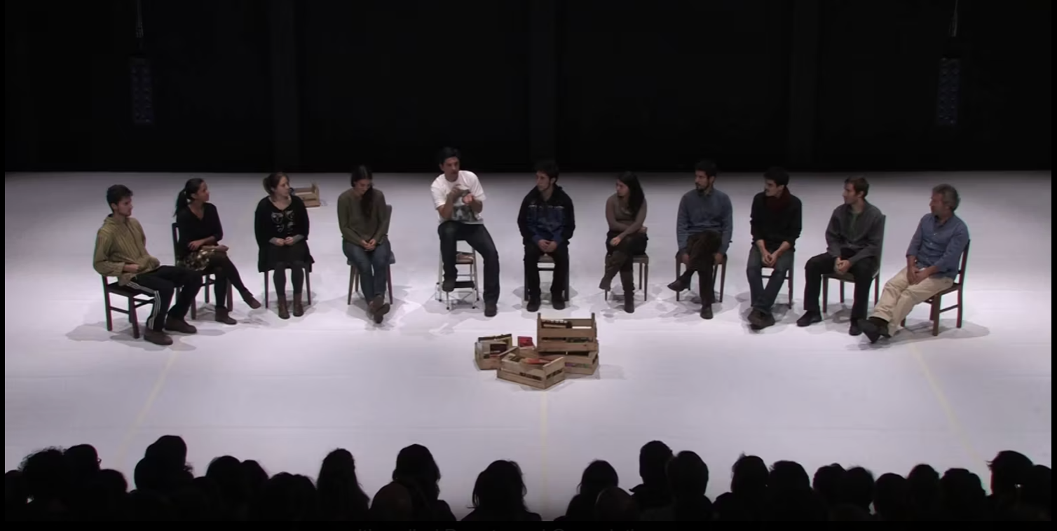

**The Performers**

This show will be performed by Tiago Rodrigues, pictured below:

**Lighting and Sound**

* The lighting for this performance remains in the same state for the whole show; it does not change.
* The performance space is well lit
* It’s a quiet show, no background music will be played, solely performer talking
* No flashing or moving lights
* No haze or smoke

**Participation**

* The performance is centred around audience participation.
* The audience members who participate in the show, will sit on stage for the entire performance, around 1 hour 45 minutes.
* Water will be provided for on-stage participants.
* The 10 audience members memorize a poem and participate on stage.
* Tiago guides the audience participants through the lines, using gestures and breaks to discuss the act of memorising and connecting it to his own life.
* The audience members speak sections of the poem out loud throughout the performance
* Towards the end of the performance, the audience participants on stage will each be asked to eat a communion wafer.

**Access Information**

* The performance is 1 hour and 45 minutes long
* There is an accessible toilet on every floor of the building
* There is a chill out space outside the performance space that is available anytime the building is open
* Ear defenders are available to borrow from the box office for anyone who might find these useful
* All performances are Relaxed, this means you can move or make noise if you need to and can go in and out of the performance space.
* Please note, that if you are a participant in the performance, you be sitting on wooden, dining room chairs (all chairs provided will have backs) and will look a little like this:

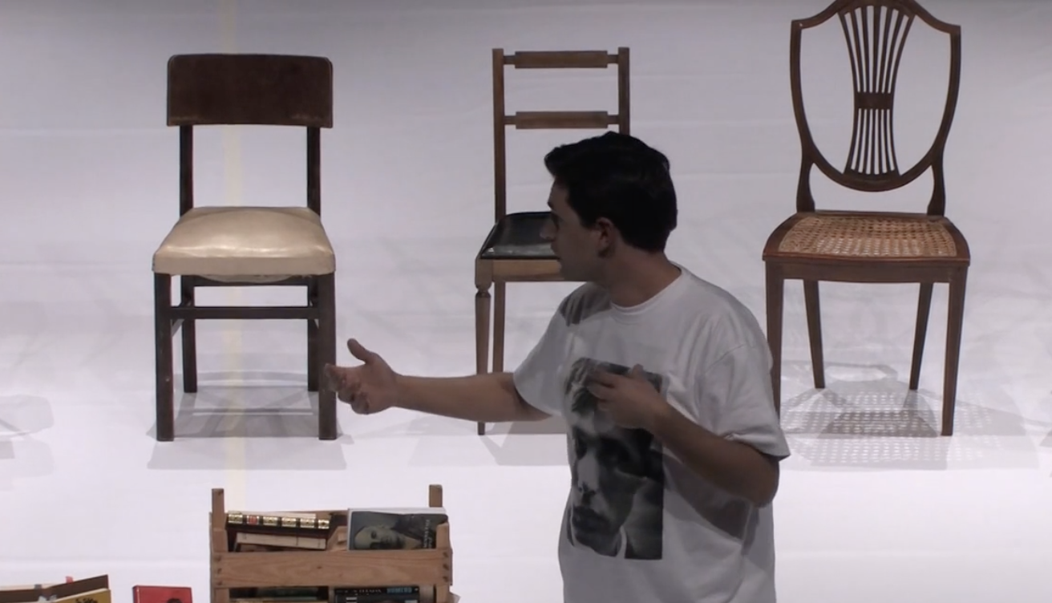

**Content Notes**

* In 'By Heart', Tiago tells us a story: that of his grandmother who, having become blind, asks her grandson to choose a book for her that she could learn by heart.
* Through literature, themes of censorship and political violence are referenced, but not described in detail.
* There is reference to the Nazi regime and mentioned of the camp Birkenau, again this is not explored in detail.
* Inspired by the book *Fahrenheit 451,* there is a description of fire and arson.
* ‘By Heart’ talks about struggle against time, forgetting and aging.