**Handle with Care – Preshow Information**

This information is to help you decide if **Handle with Care** is for you. Content notes, including what happens in the show, are further in the document.

**The Space**

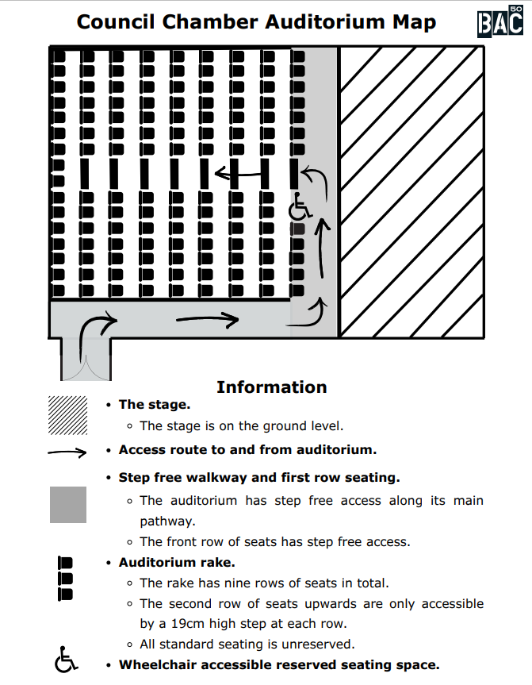

The show is in the Council Chamber, and you can see a map of the space in the picture above.

The audience will be invited to walk onto the stage to take part in the show.

The performance will happen in the middle of the stage

**The Performers**

There are no performers in ‘Handle with Care’.

Instead, the audience follows written instructions to create the show themselves.

The audience is up to 45 people.

**Lighting and Sound**

The stage and seating area in the theatre will be well lit.

There is no recorded sound used at any time during the show.

At one point music will be played from a mobile phone.

Sometimes the audience may talk over each other.

As there might be 45 people, the space may become quite loud with audience voices at points during the show.

**Participation**

There is lots of audience participation throughout the show. Audience participation is what makes the show happen.

Here is a list of things that will help you imagine what the audience participation might look like:

* On the stage there will be a box. Inside the box are all the instructions for the audience.
* One audience member will need to decide to open the box. When the box is open and the first instruction has been read, the show has started.
* Now the show has started there will be lots of instructions. You may be invited to take part in an instruction.
* The invitation is always optional, and you don’t have to take part.
* The instructions will be written in English.
* Sometimes the instruction will need to be read out loud. If you don’t want to read out loud, you can ask someone else to do it.
* If you have difficulty reading, you can ask another audience member to help you.
* Sometimes the instruction might ask you to carry out a task with objects.
* If you are struggling with the task, you can ask another audience member to help you or pass the task onto someone else.

Sometimes lots of tasks will happen at the same time. The space may feel quite busy and chaotic.

**Access Information**

The performance is between 60-90 minutes long, depending on the group.

The Council Chamber is on the first floor, but there is step-free access via the lift.

There is an accessible toilet on every floor of the building.

There are also gender neutral/all gender toilets on each floor.

There is a chill out space outside the performance space on the first floor that is available anytime the building is open.

All performances are Relaxed this means you can move or make noise if you need to and can go in and out of the performance space.

Latecomers will not be permitted

Ear defenders and fidget toys are available to borrow from the box office for anyone who might find these useful. They will also be available on a table by the entrance to the Council Chamber.

**Content Guidance**

References to death, dying and people who have died

Mentions of children and whether you can have children of your own

**Please scroll to the bottom of this document (past the blank page) to read more detailed content notes. These notes include content that is intended as a surprise.**

**Content Notes**

As we have mentioned, the show contains a lot of audience participation.

During the show, you may be invited to:

* Read a letter in your head
* Pick someone to join you on stage
* Leave and re-enter the theatre space
* Tear up paper
* Read out loud
* Hand out objects and handle objects
* Answer questions
* Write on paper
* Call someone on your mobile phone
* Put a hat on
* Shake someone’s hand
* Speak out loud
* Talk to someone and improvise a conversation together
* Improvise with the group
* Do a puzzle
* Take a photograph