Radio Live: A New Generation – Preshow Information

This information is to help you decide if Radio Live: A New Generation is for you. Content notes, including what happens in the show, are further in the document.

The Space
- The show is in the Grand Hall, the stage will be covered with white dance floor, there is also a big screen
- Audience routine and Grand Hall pictures to be uploaded soon
- The show will happen in the middle of the stage
- The show is in an interview style conversation, performers will always be on stage talking in microphones
- The audience sits front on to the stage

The Performers
This show will be performed by

Performer | Headshot
Yannick Kamanzi (performer) | 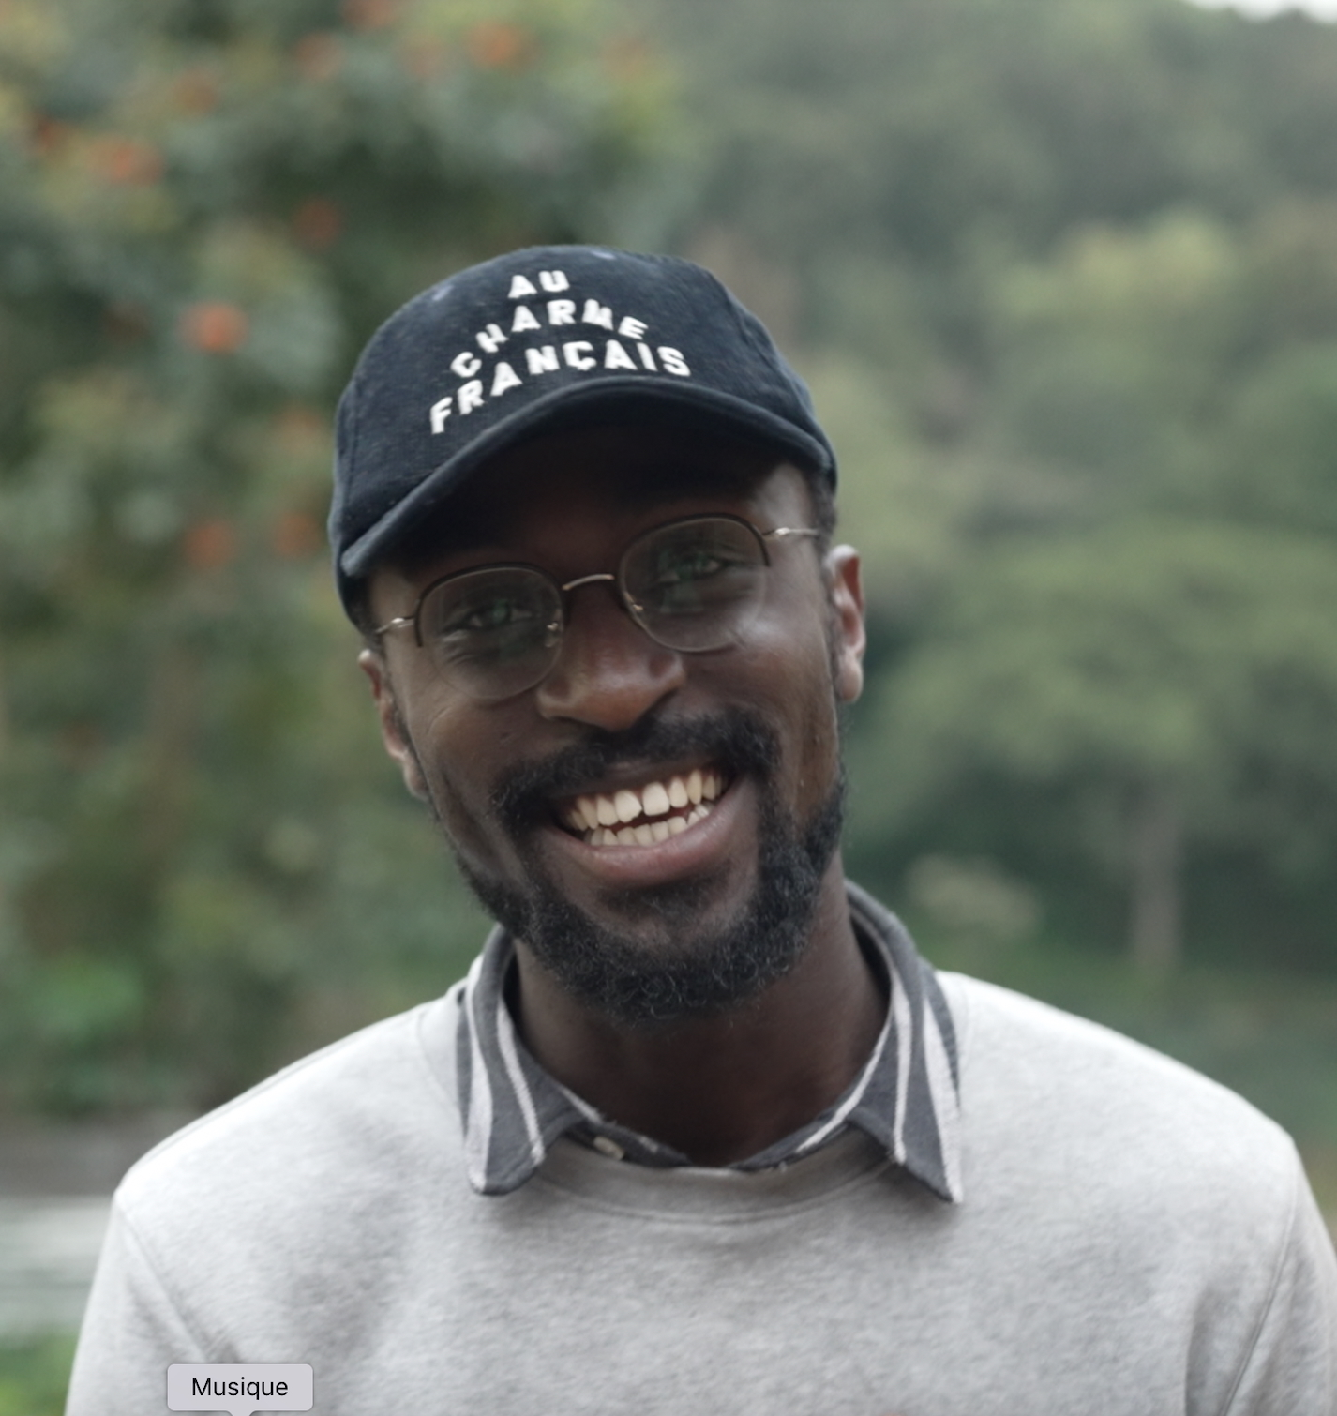
Karam Al Kafri (performer) | 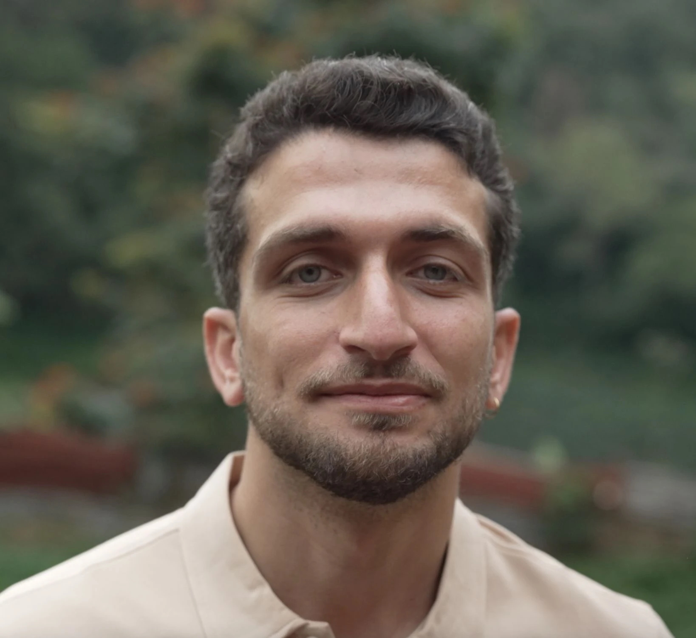
Amir Hassan (performer) | 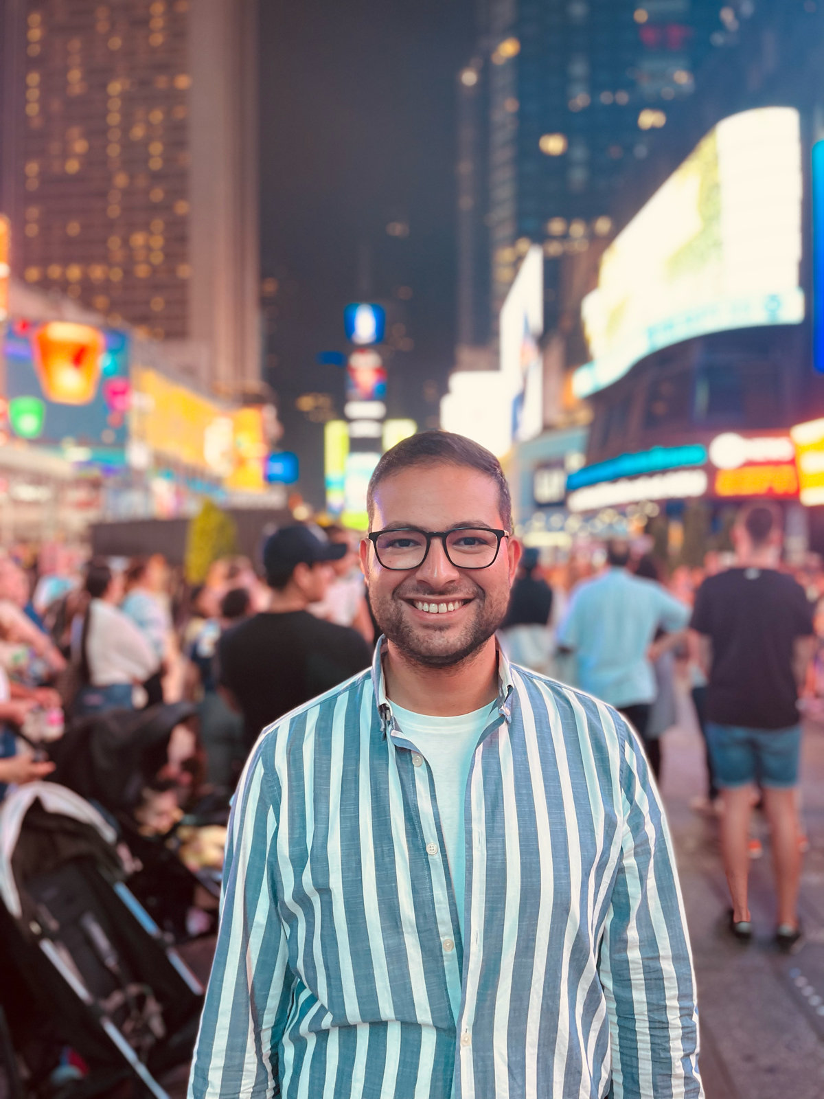
Oksana Leuta (performer) | 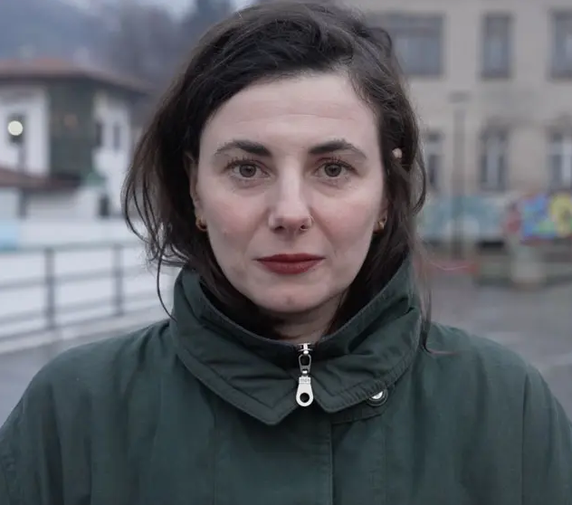
Emma Prat (company staff) | 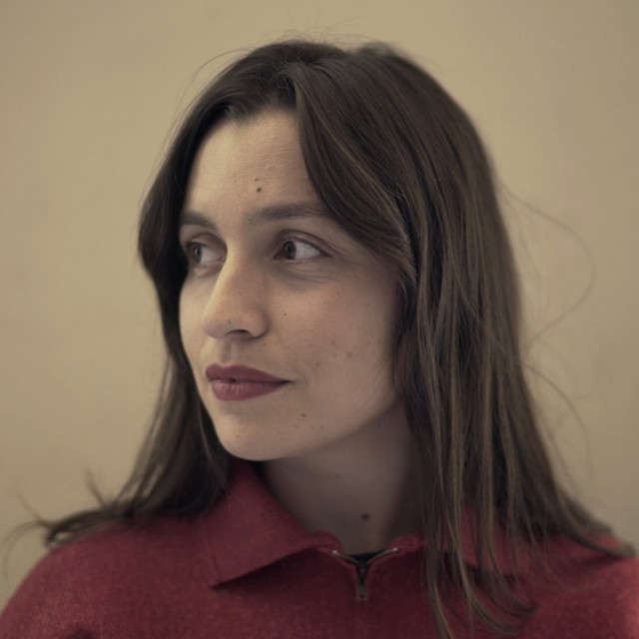
Gala Vanson (company staff) | 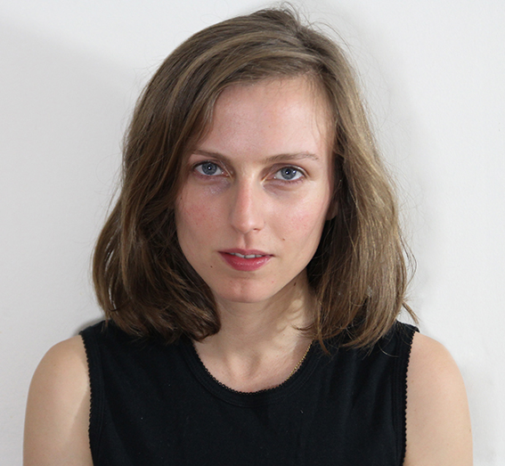
Aurélie Charon (company staff) | 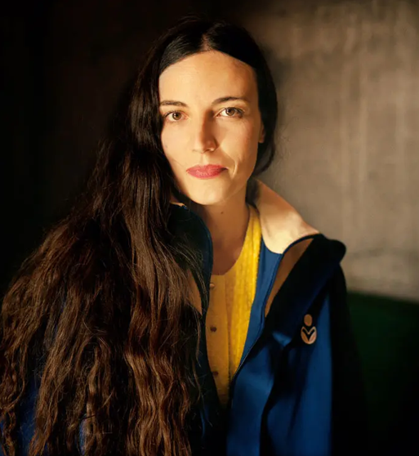

Lighting and Sound
- The performance space is well lit, there will be moving lights, no strobe
- There will be live music, and live singing
- There won’t be any sudden loud noises and sounds
- There are always sounds and videos playing in between the talking parts
- There won’t be haze or smoke

Participation
There is no audience participation.

Access Information
- The performance is 2h 10minutes long
- There is an accessible toilet on every floor of the building
- There is a chill out space outside the performance space that is available anytime the building is open
- All performances are Relaxed this means you can move or make noise if you need to and can go in and out of the performance space
- Latecomers will be permitted
- Ear defenders are available to borrow from the box office for anyone who might find these useful

Content Notes
- Some passages in the stories refer to violent historical or people’s lives, so they may not be suitable for everyone.
- The show combines sounds, images, and live conversation between young people from different countries.
- The participants are Oksana from Ukraine, Yannick from Rwanda, Karam Al Kafri from Syria, and Amir Hassan from Gaza.
- Each of them introduces a younger person from their country, creating a dialogue across generations.
- The performance includes video, unscripted conversation, live music, and live drawing.
- It mixes personal stories with bigger ideas about identity, history, and social involvement.
- The performers talk about youth, identity, resilience, politics, memory, and present-day challenges.
- Although the participants come from places affected by war and trauma, the show doesn’t aim to shock with violent images. Instead, it highlights dialogue, strength, and the hope expressed by young people.

- Performance 1:
Sat 11 Oct 19:00:
Stories from Yannick Kamanzi (Rwanda) & Saram (Syria).

- Performance 2:
Sun 12 Oct 15:00:
Stories from Amir Hassan (Gaza) & Oksana Leuta (Ukraine).

