Dan Daw Creative Projects - EXXY

This information is to help you decide if Dan Daw Creative Projects - EXXY is for you. Content notes, including what happens in the show, are further in the document.

The Space
- The show is in the Grand Hall at Battersea Arts Centre
- The performance will happen on a flat floor stage.
- The audience sits facing the stage on tiered seating.
- There is a large set that is made up of a 4.5 metre tall by 10metre wide wall at the back of the performance space. A 5.5m wide by 2.5m tall billboard hangs from the ceiling and moves up and down during the show. There is a black sprung dance floor and 3 faux bushes in clumps on the floor. At the beginning of the show a large net is hung at the front of the stage, this will move away during the performance.
- The performers are on stage throughout. The performers will enter via a door in the back wall of the set.

The Performers
This show will be performed by
Performer | Images
Dan Daw | 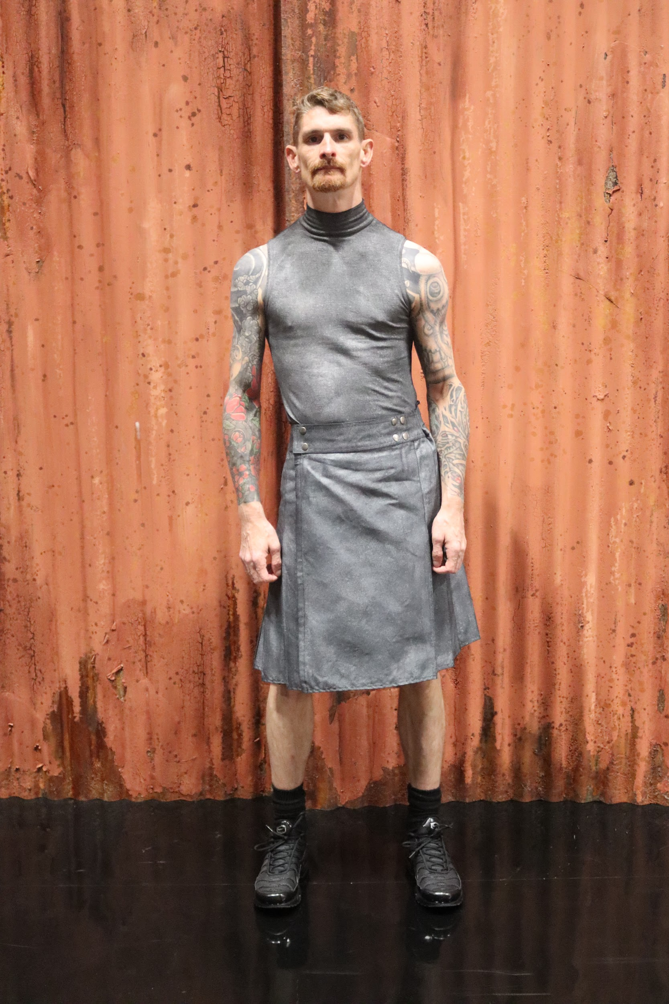
Tiiu Mortley | 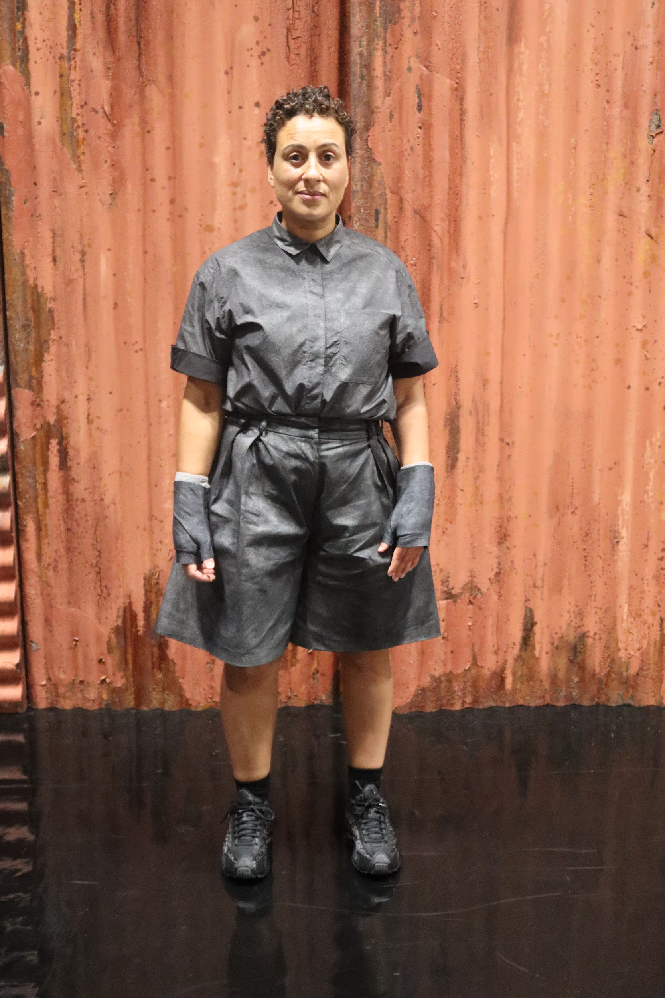
Joe Brown | 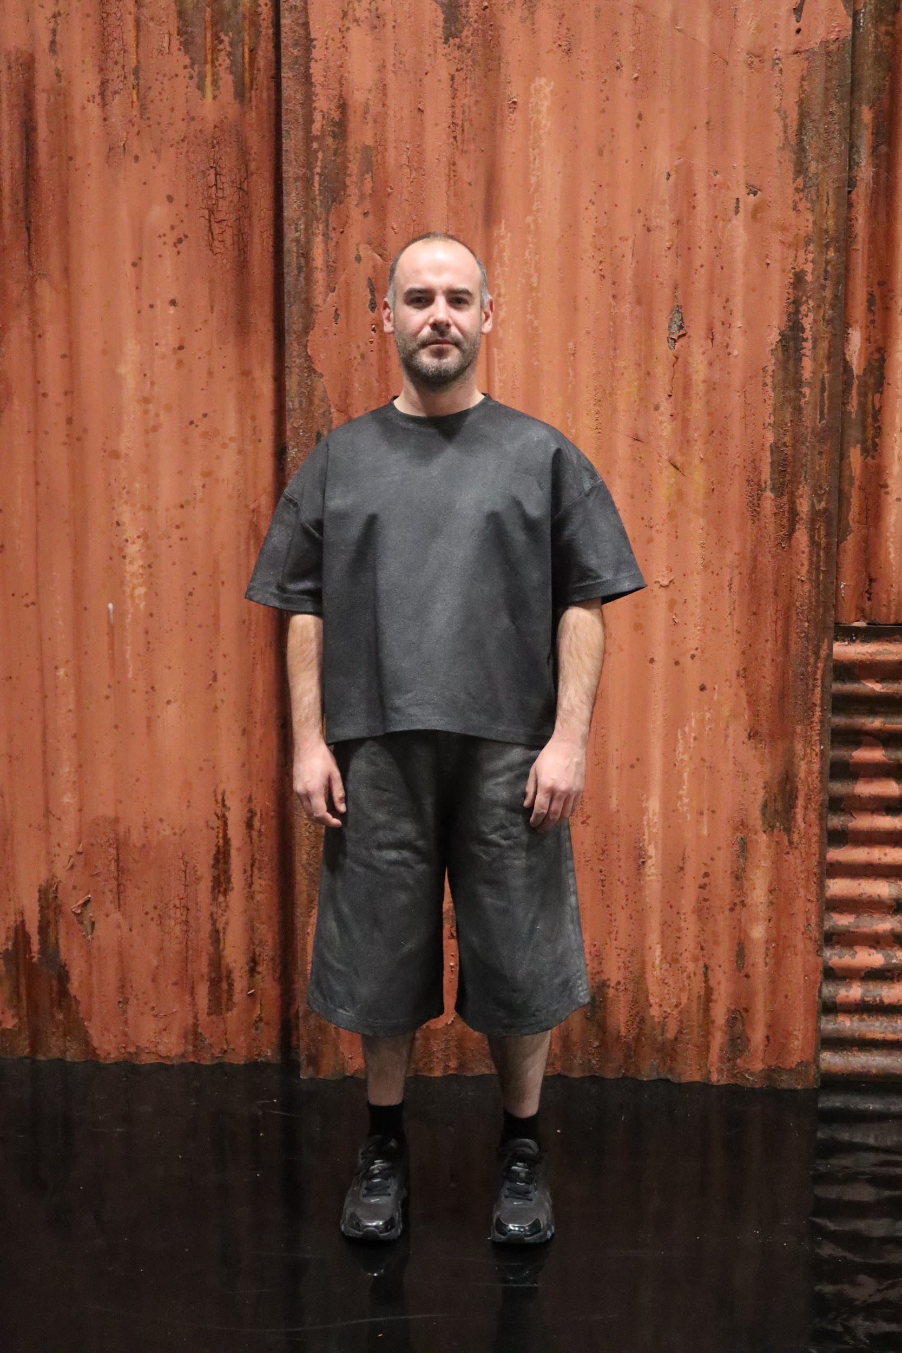
Sofía Valdiri | 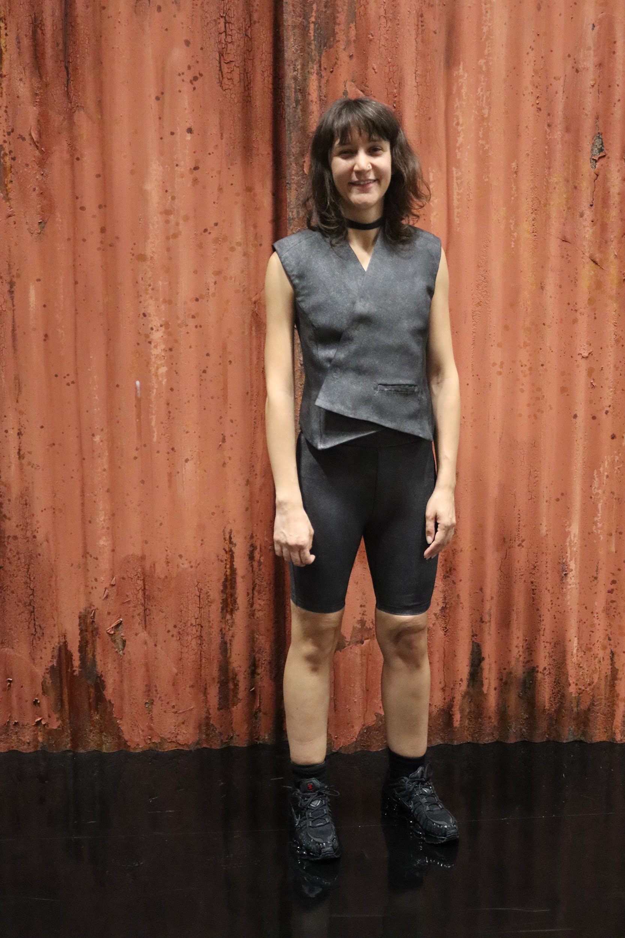
Lighting and Sound
- There will be some sudden loud noises and sounds.
- There will be music at the same time as people talking.
- There will be flashing/moving lights.
- There will be a sudden blackout.
- Haze will be used.

Participation

The performers may make eye contact with you whilst talking and ask a question of the entire audience but will not single out any one person to answer a question.

Access Information
- The performance is 75 mins long, there is no interval.
- There are captions integrated in every shows
- There is an accessible toilet on every floor of the building
- There is a ‘chill out space’ outside the performance space that is available anytime the building is open
- All performances are Relaxed this means you can move or make noise if you need to and can go in and out of the performance space
- Latecomers will be permitted
- Ear defenders are available to borrow from the pre show access table for anyone who might find these useful
- There are dark glasses available

Content Notes
- If you are bringing a guide dog or assistance dog into the performance space, please let us know!
- Dan communicates to the audience and you can choose whether to respond or not.
- There will be discussion of upsetting topics - These are all handled with sensitivity, and the intention is to raise awareness and care, rather than to shock or upset
- The show is made up of several short dance pieces, including solos, duets and a group performance.
- One of the performers briefly speaks in Spanish and then French.

Trigger Warnings
Loud Noises
Bright, intense and/or flashing lighting effects
Flashing/moving images and video
Sudden and rapid movement of objects around the stage, towards audience
Coins
Long silences
Total black outs
Feeling/description of being othered
Excessive and up close drool/spit
Haze
Reaching physical exhaustion
Scenes that can be interpreted as the performers being in pain

