Title – Preshow Information

This information is to help you decide if Merry Misrules is for you. Content notes, including what happens in the show, are further in the document.

The Space

- This performance is immersive, and you will follow the characters as they move through four different rooms, telling their story.
- You will be guide through these rooms, full of various props and set pieces.

The Performers

This show will be performed by

Name | Headshot
Rabbit | 
Pigeon | 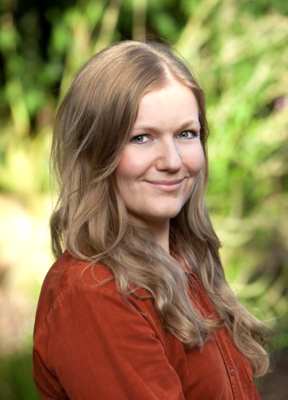
Mouse | 
Understudy | 

Lighting and Sound
- The performance space is well lit.
- There will be haze.
- There is music at the same time as people talking.
- Flashing or moving lights pending.
- The show is in development, sound level of the show is pending. For all sensory adapted shows, lighting and sound level will be reduced.

Participation
There is audience participation. This is always optional.

Access Information
- The performance is 40 minutes long
- There is an accessible toilet on every floor of the building
- There is a chill out space outside the performance space that is available anytime the building is open
- All performances are Relaxed this means you can move or make noise if you need to and can go in and out of the performance space
- Latecomers will be permitted
- Ear defenders are available to borrow from the box office for anyone who might find these useful

Content Notes
- Anti Consumerism

