Title – Preshow Information

This information is to help you decide if Monica is for you. Content notes, including what happens in the show, are further in the document.

The Space
- The show is in the Council Chamber
- The performance will happen in the middle of the stage
- The audience sits front on to the stage
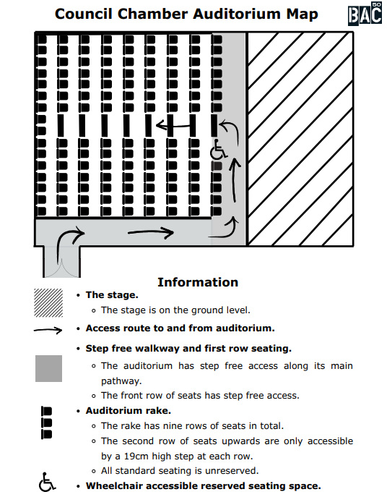

The Performers
This show will be performed by
Name | Headshot
Pablo | 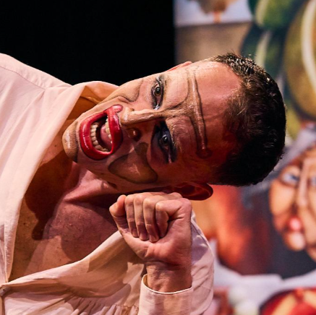
Fede | 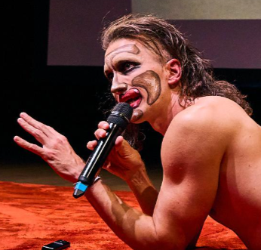

Lighting and Sound
- The performance space is well lit
- There are no extremely loud sounds, but sometimes it is quite loud
- There are no sudden changes in the sound levels
- There will be haze
- There is music playing at the same time as performers are talking

Participation
There is no audience participation.

Access Information
- The performance is 90 minutes long
- There is an accessible toilet on every floor of the building
- There is a chill out space outside the performance space that is available anytime the building is open
- All performances are Relaxed this means you can move or make noise if you need to and can go in and out of the performance space
- Latecomers will be permitted
- Ear defenders are available to borrow from the box office for anyone who might find these useful

Content Notes
- Nudity
- Mentions of cancer
- Mentions of Nazism
- Mentions of Political persecution
- Family history of immigration, diaspora, and refugees
- Patriarchal and historical narratives
- Miscarriage

