The Present Is Not Enough – Preshow Information

This information is to help you decide if The Present Is Not Enough is for you. Content notes, including what happens in the show, are further in the document.

The Space
- The show is in the Council Chamber
- The audience sits on three sides of the performance space
- It will be a mixture of sitting on the floor on foam matting and chairs.
- This is how the space will be arranged:

The Performers
This show will be performed by
Name | Headshot
Silvia Calderoni | 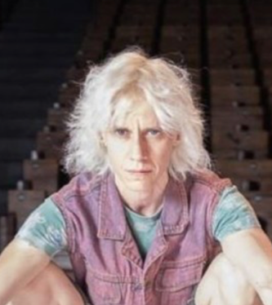
Ilenia Caleo | 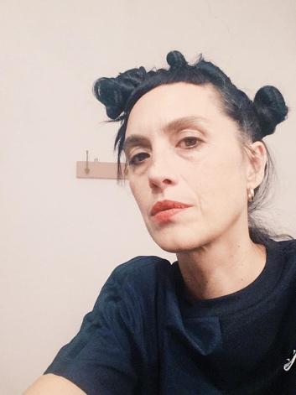
Gabriele Lepera | 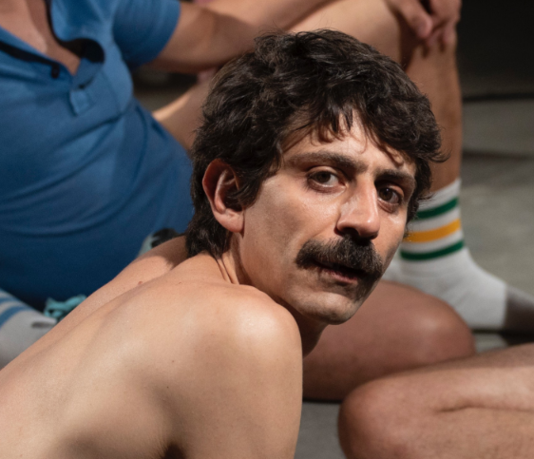
Fedra Morini | 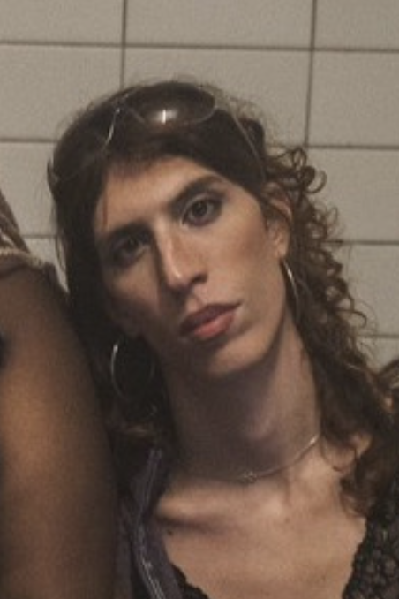
Nico Guerzoni | 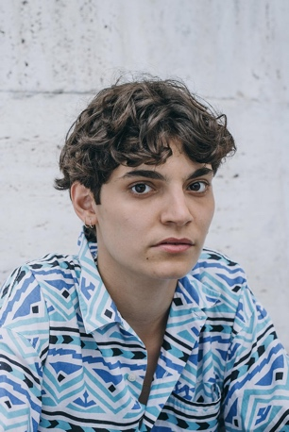
Tony Allotta | 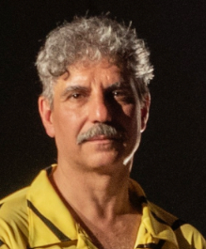
Ondina Quadri | 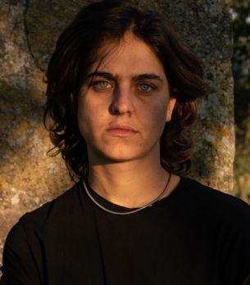

Lighting and Sound
- The performance space is well lit.
- There will be flashing and moving lights; no strobe lighting.
- There will be some lighting blackouts of varying durations.
- There will be loud or sudden music and sounds.
- Performer will sing at the end of performance.

Participation
There is no audience participation.

Access Information
- The performance is 60 minutes long
- The performance is not a relaxed performance
- No late comers will be permitted
- If you leave the space, readdmittance may not be possible
- There is an accessible toilet on every floor of the building
- There is a chill out space outside the performance space that is available anytime the building is open
- Ear defenders are available to borrow from the box office for anyone who might find these useful

Content Notes
- Nudity
- LGBTQIA+ themes, including lesbian viewpoints and ways of understanding the world
- Ideas about a hopeful or ideal queer future and related feelings
- Creative use of historical queer materials, like photos and stories (from New York piers in the 1980s)
- References to punk culture and AIDS activism

