What To Expect When You’re Not Expecting
– Preshow Information

This information is to help you decide if What To Expect When You’re Not Expecting is for you. Content notes, including what happens in the show, are further in the document.

The Space
- The show is in the Council Chamber
- The performance will happen in the middle of the stage
- The audience sits front on to the stage
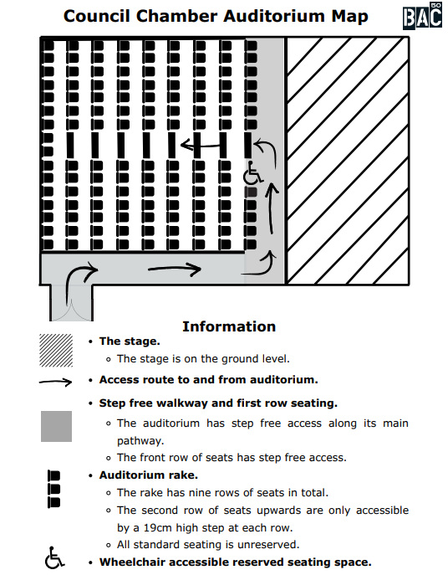

The Performers
This show will be performed by Louise Ashcroft

Lighting and Sound
- There will be moving lights
- There is one sudden loud sound effect
- The performance space is well lit
- Sometimes there is music at the same time as people talking

Participation
There is no audience participation

Access Information
- The performance is 1hour long
- There is an accessible toilet on every floor of the building
- There is a chill out space outside the performance space that is available anytime the building is open
- All performances are Relaxed this means you can move or make noise if you need to and can go in and out of the performance space
- Latecomers will be permitted
- Ear defenders are available to borrow from the box office for anyone who might find these useful

Content Notes
- Strong language and adult humor.
- References to fertility issues, including sperm donation and non-traditional routes to parenthood.
- References to bisexuality, infertility, childlessness, and worries about becoming a mother

