Second Trimester – Preshow Information

This information is to help you decide if Second Trimester is for you. Content notes, including what happens in the show, are further in the document.

The Space
The show is in the Council Chamber
The performance will happen in the middle of the stage
The audience sits front on to the stage
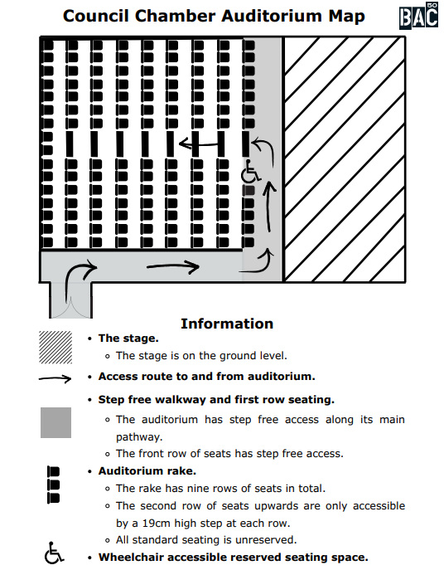

WELLBEING SPACE
We understand that Second Trimester explores challenging themes. For this reason, a Wellbeing Space will be available throughout each performance and for 45 minutes afterwards.

The Wellbeing Space will be located on the ground floor in Elm House. There will be a sign and a member of the Front of House team can direct you.

A wellbeing practitioner, Sabah Choudrey, will also be on hand to offer additional support if needed. For the BSL interpreted performance, BSL interpreter Grace Buckle will be working alongside Sabah.
On 17th & 22nd April Lizzie Wedderburn will be the wellbeing practitioner.

The Performers
This show will be performed by
Name | Headshot
Krishna Istha  &  Geetha Shankar | 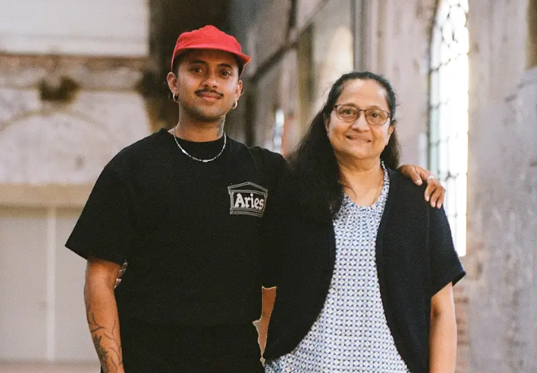

Lighting and Sound
- There are lights on each side of the stage as well as above
- There are also LED strip lights around the set. The performance space is well lit and at moments some of the audience may also be lit
- There is video projection throughout the show which involves some film grain effect and sudden moving images
- There will be loud music
- There may be sudden loud noises as part of the sound design of the show
- There will be flashing lights
- There will be haze
- There will be music at the same time as people talking
- Songs and sound effects shall be played over the sound system
- A performer will sing/hum a song onstage as part of the performance without amplification

Participation
There is no audience participation, though audience will be spoken to directly as part of the performance

Access Information
- The performance is 1 hour and 30 minutes long (no interval)
- There will be Live Captioning performances taking place on Saturday 18 April at 7:30pm and Friday 24 April at 7:30pm. Live captioned by Nicola Dutton.
- There will be a BSL interpreted performance taking place on Friday 24 April at 7:30pm. Interpreted by Pettra St Hilaire.
- There will be an Audio Described performance taking place on Friday 24 April at 7:30pm and Saturday 25 April at 7:30pm. Described by Shivaangee Agrawal.

PRE-SHOW ACCESS SESSIONS
- There will be Pre-Show Access Sessions on the following dates and times: Friday 24 April – 6:30-7:00pm and Saturday 25 April- 6:30-7:00pm
- These pre-show Access Sessions will be led by Audio Describer Shivaangee Agrawal. They will incorporate a touch tour and sensory introductions to the themes and costumes in the show. These will be accessible for blind and visually impaired patrons, as well as any other audience members that may benefit from easing into the evening.
- There is an accessible toilet on every floor of the building
- There is a chill out space outside the performance space that is available anytime the building is open
- All performances are Relaxed this means you can move or make noise if you need to and can go in and out of the performance space
- Latecomers will be admitted but may be asked to wait until a suitable break in the performance
- Ear defenders are available to borrow from the box office for anyone who might find these useful. Babies are welcome in the space but ear defenders are recommended as there are loud noises.

Content Notes
- Child loss,
- Fertility issues,
- Transphobia,
- Racism
This show is still in development and content guidance may be subject to change.

