Dance Me to the End of Love – Preshow Information

This information is to help you decide if Dance Me to the End of Love is for you. Content notes, including what happens in the show, are further in the document.

The Space
- The show will happen across Rec Room, Committee Room, Members Library
- The audience will move through the building with the performers.
- The performers are blindfolded for much of the performance.
- A soundtrack begins before the audience enters and continues throughout the performance.

The Performers
This show will be performed by
Pink Suits 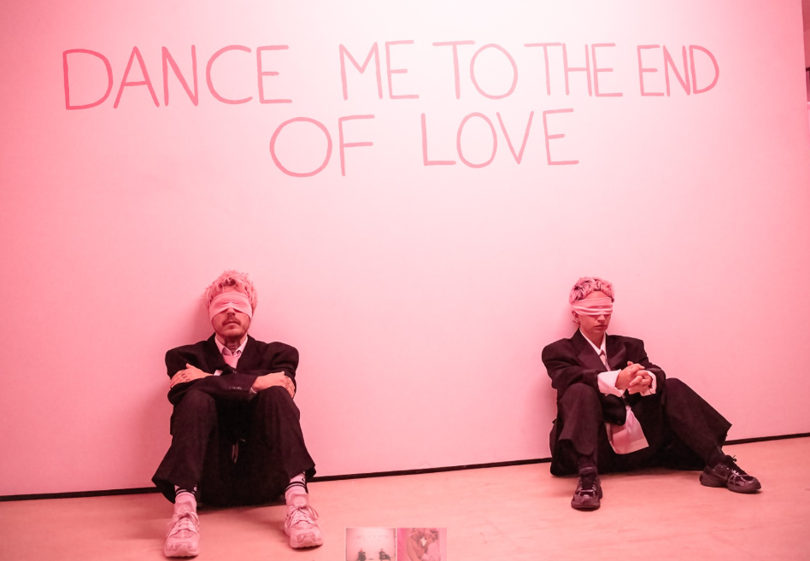

Lighting and Sound
- The performance space is well lit
- The sound is a live concert, with songs and chat in between
- There are singer talks over the live music

Participation
- Audience members are invited to write notes and peg them to a clothes wire.
- Audience members may also be invited to sing along.
- Participation is always optional.

Access Information
- The performance is 90 minutes long
- There is an accessible toilet on every floor of the building
- There is a chill out space outside the performance space that is available anytime the building is open
- All performances are Relaxed this means you can move or make noise if you need to and can go in and out of the performance space
- Latecomers will be permitted
- Ear defenders are available to borrow from the box office for anyone who might find these useful

Content Notes
This show is still in development and content guidance may be subject to change:
- Body piercing
- Possibility of Blood
- Nudity
- Nude/Sexual imagery
- Acts of physical violence
- Audience participation (optional)

If you want to know more about what’s happening in the show, please scroll to next page:

What Happens in the Show
The performance lasts approximately 90 minutes and includes movement between spaces.

Members Library
- The performance begins in the Members Library.
- Both performers are blindfolded.
- There is approximately 15 minutes of dancing.

Committee Room
- The audience and performers move together into the Committee Room.
- There is approximately 10 minutes of dancing in this space.

Rec Room
- The audience and performers then move into the Rec Room.
- There is a clothes wire with socks and underwear hanging in the space.
- Pink paper covers the floor.
- A curtain with peepholes is closed for part of the performance, and the audience watches actions taking place behind the curtain.
Actions behind the curtain include:
- Stapling to the body
- Slapping the face
- Choking gestures to the face
- The curtain then opens and there is approximately 5 more minutes of dancing.
- The performers remove their blindfolds.
- Audience members are invited to write on the pink paper from the floor and peg it onto the clothes wire. Participation is optional.
- The performers complete another dance section before running out of the room.

Return to the Committee Room
- The audience returns to the Committee Room.
- Audience members are given music stands and invited to sing with Lennie. Participation is optional.
- During this section, Ray cuts onions.
- Waltz Procession - The performers begin a waltz in the Committee Room and move back through the building into the Members Library.

Final Sections
- The performance includes a rage room section.
- In the final dance, the performers place pillows over their heads.

