FAMEHUNGRY – Preshow Information

This information is to help you decide if FAMEHUNGRY is for you. Content notes, including what happens in the show, are further in the document.

The Space
- The show is in the Council Chamber
- The performance will happen in the middle of the stage
- The audience sits front on to the stage
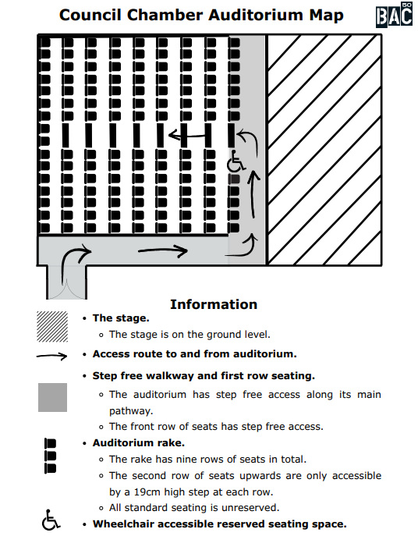

The Performers
This show will be performed by
Louise Orwin 

Lighting and Sound
- There are dark moments at the beginning and middle of the show
- There is flashing lights
- There is haze
- The show is loud
- There is music at the same time as people talking
- There is song played over the sound system

Participation
There is no audience participation.
However, at the end of the show, Louise briefly shows the in-person audience to the TikTok livestream. The audience is also visible on TikTok as they enter the theatre.

Access Information
- The performance is 80 minutes long
- There will be a Live Captioning performance on 16 May by Euan Williams.
- There is an accessible toilet on every floor of the building
- There is a chill-out space outside the performance space that is available anytime the building is open
- All performances are Relaxed this means you can move or make noise if you need to and can go in and out of the performance space
- Latecomers will be permitted
- Ear defenders are available to borrow from the box office for anyone who might find these useful

Content Notes
- The show will be live streamed in TikTok throughout
- The show is about fame, the attention economy and how social media distract us
- There will be strong language, nude and sexual organ images displayed quickly
- Representations of death and suicide

