Matter Era – Preshow Information

This information is to help you decide if Matter Era is for you. Content notes, including what happens in the show, are further in the document.

The Space
- The show is in the Members Bar
- The performance will happen in the middle of the stage on a raised square stage
- The audience is able to move around the stage on all sides
- One side of the stage will have seating options
- One side of the stage will have a raised platform to stand on
- 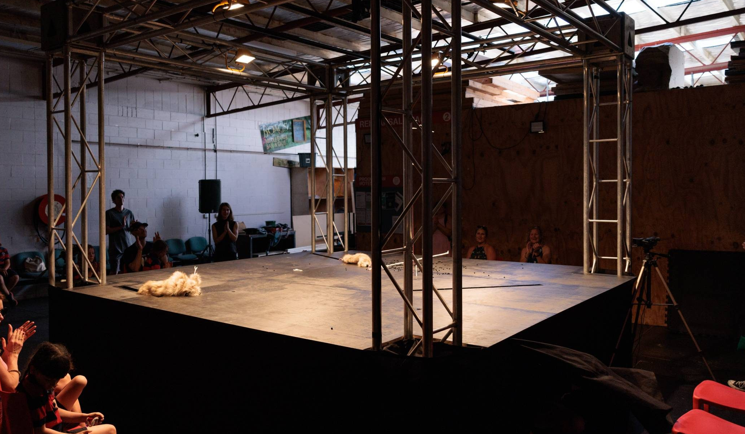

The Performers
This show will be performed by Tasmanian puppeteers Terrapin. You will not see the performers but you will see the puppets they puppeteer
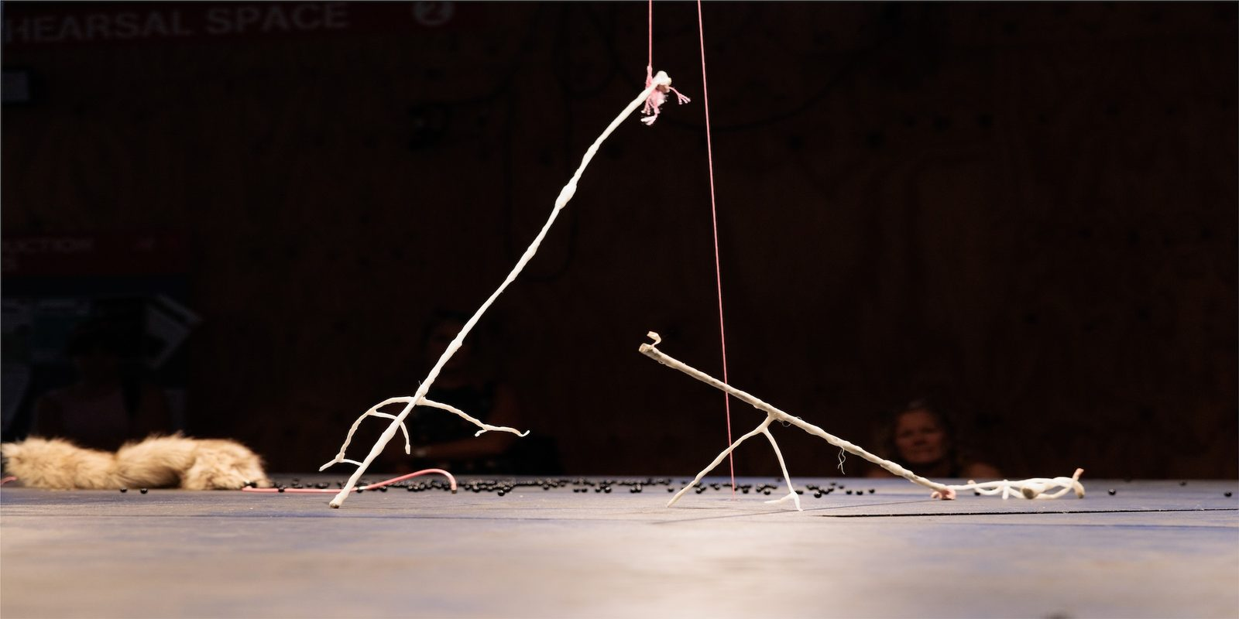

Lighting and Sound
- The stage is well lit by a grid of lights above the stage which provide coverage over the full stage
- There are also occasionally brighter lights shining across the stage including at the start of the show and at points throughout
- There is a continuous score of electronic and keyboard music. This is performed live and played through speakers around the space, with synth and sound effects distorting the music throughout
- There are no other sound effects but you will occasionally hear the sound of the puppeteering and the puppets moving onstage
- There may be flashing lights as part of the performance
- There is haze

Participation
There is no audience participation but audience are welcome and encouraged to walk around the space and view the stage from different positions.

Access Information
- The performance is 1h long, the durational performance lasts 5h.
- There is an accessible toilet on every floor of the building
- There is a chill out space outside the performance space that is available anytime the building is open
- All performances are Relaxed this means you can move or make noise if you need to and can go in and out of the performance space
- Latecomers will be permitted
- Ear defenders are available to borrow from the box office for anyone who might find these useful

Content Notes
- This is a puppeteering piece exploring a post-human world where inanimate objects take on life, through being puppeteered by performers
- At first there will be a bare stage that will steadily be occupied by different objects and puppets. These puppets will move around the stage both solo and in interaction with each other, and will come and go from the stage.
- There will be different stages to the development of puppeteering and different kinds of puppets and techniques throughout the performance
- The puppets are non-anthropomorphic and do not have faces, characters or voices
- The show is in development and so information, whilst up to date at the time of writing, may change before the performance

