Wormhole Of Our Formation – Preshow Information

This information is to help you decide if Wormhole Of Our Formation is for you. Content notes, including what happens in the show, are further in the document.

The Space
- The show is in the Council Chamber
- The performance will happen in the middle of the stage
- The audience sits front on to the stage
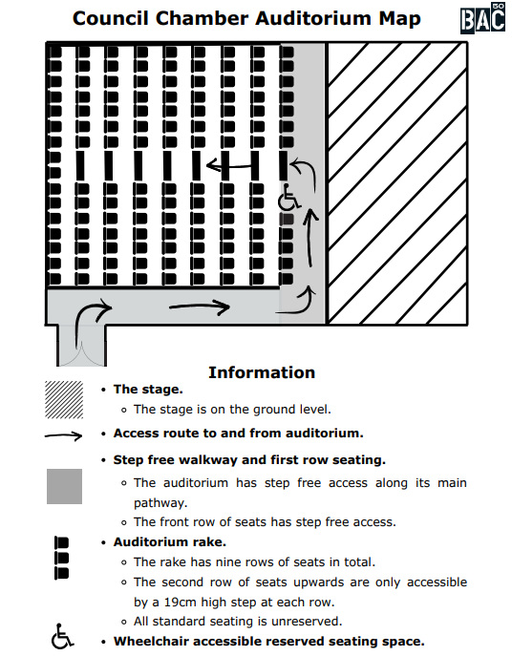

The Performers
This show will be performed by
Catherine Hoffmann

Lighting and Sound
- The performer is well lit.
- There will be some flashing lights in 15mins.
- The show is generally loud and there are some very loud moments
- Music is played over the sound system.
- There is music at the same time as people talking.
- There is live singing between 7mins.
- There will be consistent sharp alarm sounds between 15-18 mins.

Participation
There is no audience participation

Access Information
- The performance is 40 minutes long
- This performance is not relaxed, meaning latecomers will not be admitted into the space after the show starts
- There will be Captioning performance on 8th and 9th May.
- There is an accessible toilet on every floor of the building
- There is a chill-out space outside the performance space that is available anytime the building is open.
- Ear defenders are available to borrow from the box office for anyone who might find these useful.

Content Notes
- Themes of mental health, aging and austerity
- References to medical conditions

