Good Sex – Preshow Information

This information is to help you decide if Good Sex is for you. Content notes, including what happens in the show, are further in the document.

The Space
- The show is in the Grand Hall
- The performance will happen in the middle of the stage
- The audience sits front on to the stage

The Performers
This show will be performed by
Name | Headshot
Intimacy director | 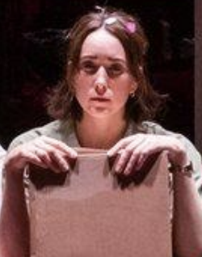
Barry | 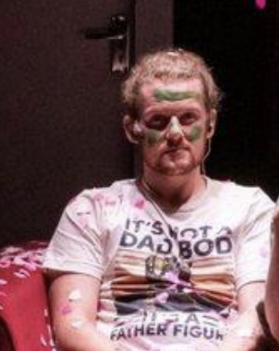
Alex | 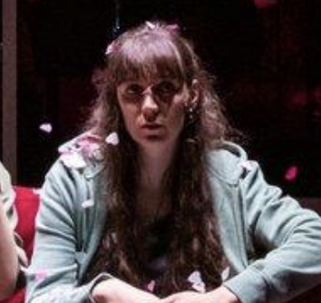

Lighting and Sound
- The performance space is well lit
- There will be haze
- There is music at the same time as people talking
- A song is played over the sound system

Participation
The audience will be asked to mimic animal voices, but people can choose to participate or not.

Access Information
- The performance is 80 minutes long, with no interval
- There is an accessible toilet on every floor of the building
- There is a chill out space outside the performance space that is available anytime the building is open
- All performances are Relaxed this means you can move or make noise if you need to and can go in and out of the performance space
- Latecomers will be permitted
- Ear defenders are available to borrow from the box office for anyone who might find these useful
- There will be an BSL interpreted performance on Thursday 5 Nov at 7:30pm. Interpreted by Ali Gordan.

Content Notes
- Haze
- Simulated sex
- Strong language
- Themes of a mature nature
- Partial Nudity
- Smoking

Detailed Content Guidance
Good Sex explores themes of desire, intimacy, betrayal and loneliness, and includes frequent discussion of sex, relationships and physical connection.
Each performance features two performers who have never rehearsed together and have not read the script in advance. Throughout the show, they receive lines and cues through earpieces that guide them on what to say and do.
The performers are joined on stage by an Intimacy Director, who supports and guides all moments of physical contact. The production includes simulated intimacy and discussions of sexual experiences, but all physical interaction is carefully choreographed, consensual and overseen by the Intimacy Director.
Created in response to a period when physical touch became restricted and our bodies were often viewed as sources of risk or illness, Good Sex examines how we connect with one another in a world shaped by isolation, longing and uncertainty. The performance invites audiences to reflect on intimacy, vulnerability and human connection in contemporary life.
The production contains mature themes and content of a sexual nature and is recommended for audiences aged 14+.

