NINA– Preshow Information

This information is to help you decide if NINA is for you. Content notes, including what happens in the show, are further in the document.

The Space
- The show is in the Council Chamber
- The performance will happen in the middle of the stage
- Some of the performance happens in a booth at the top seating area
- Sometimes the actors move up and down the seating area and perform on the stairs
- The audience sits in front on to the stage

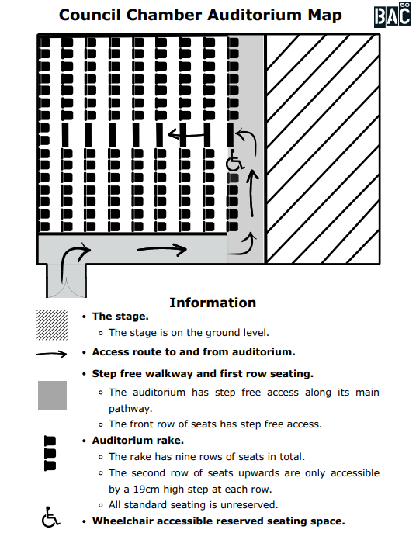

The Performers
This show will be performed by
Name | Headshot
Maya Bartley O’ Dea | 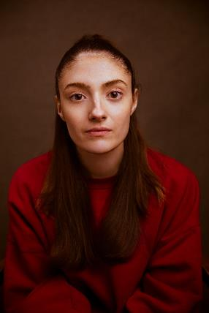
Samantha Begeman | 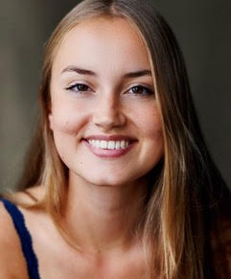
Nina Bowers | 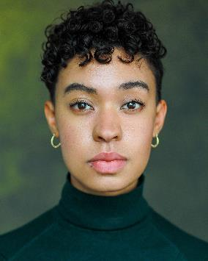
Gemma Barnett | 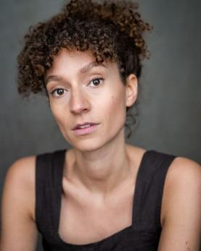
Joseph Payne | 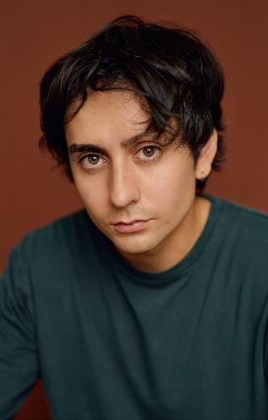
Rowan Polonski | 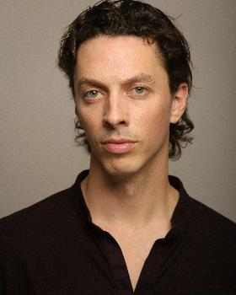

Lighting and Sound
- The performance space is well lit throughout the show.
- The performance space gets darker in between scenes
- Music is played between scene changes over the sound system
- There are three loud, unexpected gunshot noises
- There is haze used in parts of the show
- There are no flashing lights

Participation
There is no audience participation

Access Information
- The performance is 1 hour 30 minutes long
- There is an accessible toilet on every floor of the building
- There is a chill out space outside the performance space that is available anytime the building is open
- This performance is not a relaxed performance
- Latecomers will only be permitted at certain moments in the performance
- Ear defenders are available to borrow from the box office for anyone who might find these useful
- There will be a BSL interpreted performance on Thursday 15th October, during the evening performance & Saturday 24th October, during the afternoon performance. The BSL interpreter will be Sue MacLaine

Content Notes

NINA is a show about how theatre is made. There are four actresses and they are auditioning to play Nina, a character from The Seagull by Anton Chekhov. They are auditioning for a director who is charming but can also be pressuring and manipulative. NINA uses humour, play and imaginative theatre-making. Some parts of the show may feel unsettling or uncomfortable.

The show includes:
- Gunshots
- Blood
- Scene depicting masturbation
- Scene depicting childbirth
- Reference to child death
- Reference to abortion
- Depiction of dead animals

Scroll down to the next page for more detailed content guidance

Detailed content notes:

- In the first scene there is a loud unexpected gun shot.
- In the first scene an actor performs in the seating area, but there is no audience interaction.
- At the end of scene two a dead seagull falls from the ceiling. The seagull is fake but looks real.
- In scene three these themes are discussed or referenced:
  - Grief and death
  - Pregnancy and abortion
- In scene three there is a scene where the actor pretends to give birth.
- In scene four an actor pretends to kill a fake seagull. The fake seagull is pushed into a suitcase, and it sounds like the bones are cracking.
- In scene six the actor pretends to masturbate. You only see her face on a screen. The character asks to stop but isn’t allowed, which distresses her.
- In scene seven the actors act out a fight. Furniture is thrown around the space.
- In scene eight, a fake gun is used and there is the sound of gunshots.

