The Dark – Preshow Information

This information is to help you decide if The Dark is for you. Content notes, including what happens in the show, are further in the document.

The Space
- The show is in the Council Chamber
- The performance will happen in the middle of the stage
- The audience sits front on to the stage
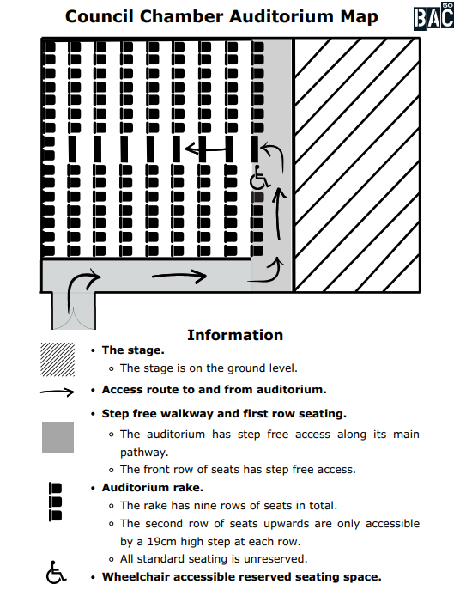

The Performers
This show will be performed by

Name | Headshot
Laszlo
Ellie / The Dark

Lighting and Sound
- There are a few short moments of complete darkness and some extended scenes where the stage is dimly lit, when Laszlo meets The Dark.
- There will be moving lights, and a torch flickers.
- There are a few loud sounds which can be surprising for audiences.
- There will be sound effect made by performer throughout the show.
- Is there background music at the same time as people talking.
- A song is played over the sound system.
- Sometimes there is live singing.
- At the beginning of the show, the performers introduce themselves and their characters. Together with the audience, they explore some of the lights and sounds that will be used during the performance, helping everyone know what to expect.

Participation
There is no audience participation.
The performers introduce themselves at the start of the show, say hello to the children, and have a brief conversation about being afraid of the dark.

Access Information
- The performance is 50 minutes long
- There is an accessible toilet on every floor of the building
- There is a chill out space outside the performance space that is available anytime the building is open
- All performances are Relaxed this means you can move or make noise if you need to and can go in and out of the performance space
- Latecomers will be permitted
- Ear defenders are available to borrow from the box office for anyone who might find these useful
- The show is integrated with Audio Description.
- There will be Pre-Show Touch Tours available for the following performances:
- Tues 27 Oct at 1:30pm
- Weds 28 Oct at 10am
- Thurs 29 Oct at 1:30pm
- Fri 30 Oct at 10am
- Sat 31 Oct at 1:30pm

Content Notes
- Laszlo, the main character, is a little boy who is afraid of the dark. He talks about his fear openly at the beginning of the show.
- There are a few short moments of complete darkness and some extended scenes where the stage is dimly lit, when Laszlo meets The Dark.
- The Dark is not intended to be a scary show, but fear is an important theme. The story explores what it feels like to be afraid and how we can learn to face and overcome our fears.

